Week 2: IPsec VPN Configuration
Task: Establish an IPsec VPN tunnel between two FortiGate devices.
We established this topology:
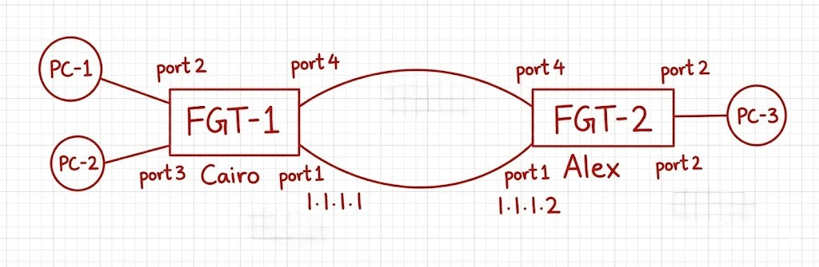
VPN tunnel
20.20.20.2
10.10.10.2
30.30.30.2
Configuration:
- Configure the interfaces and make port 1 is the management port
Cairo:
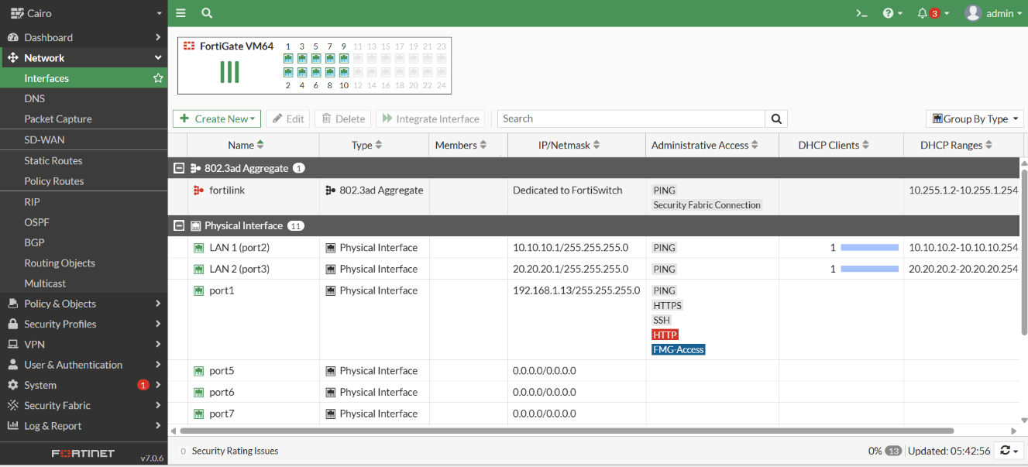
Alex:
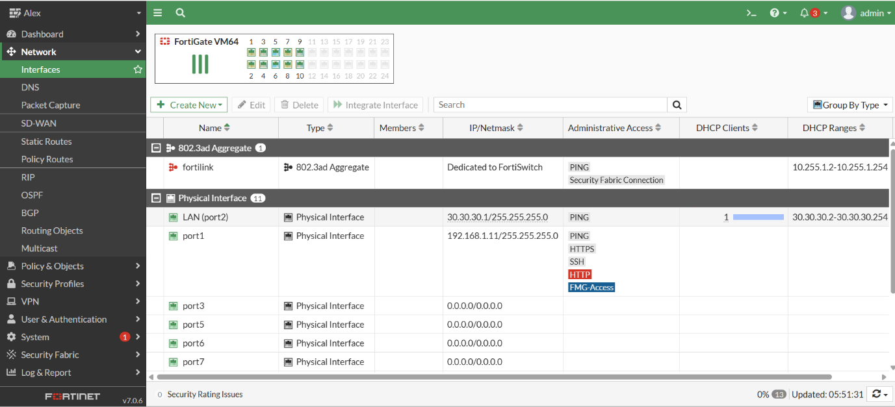
- Configure the vpn tunnel between the two firewalls and choose traffic selector from the network 10.10.10.0 to 30.30.30.0 in Cairo firewall and reverse in the Alex firewall
Cairo:
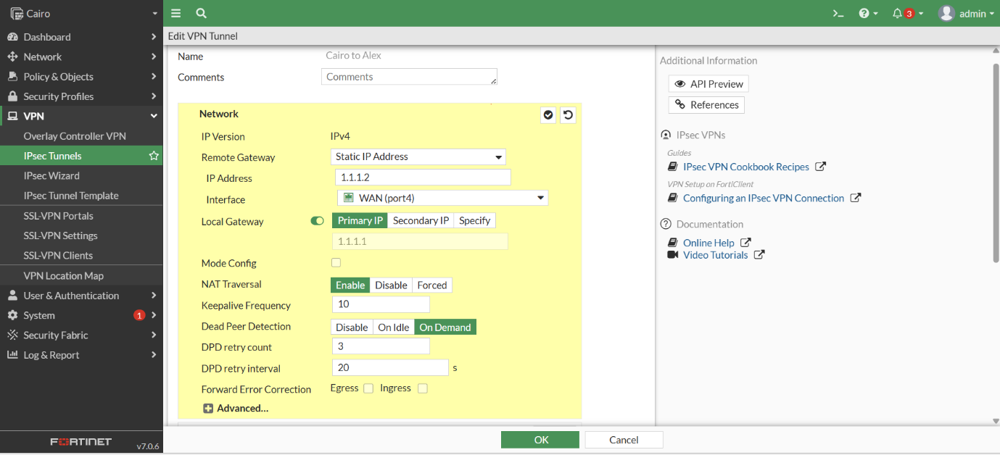
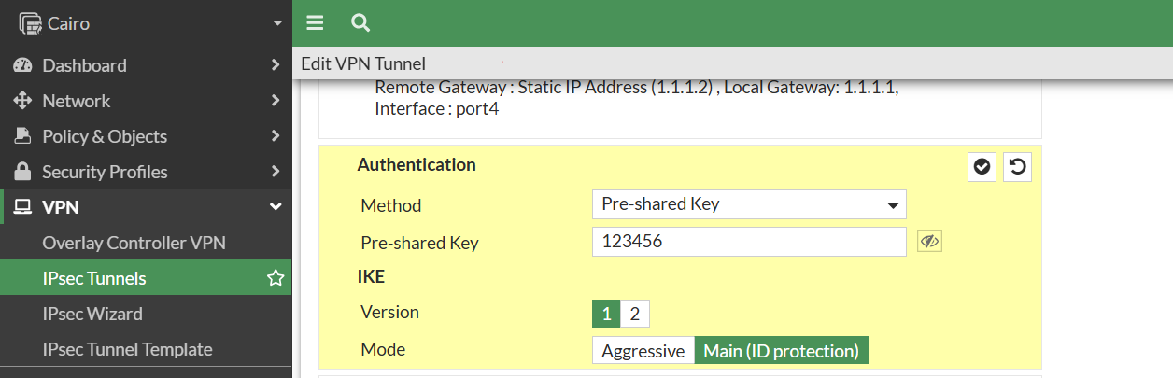
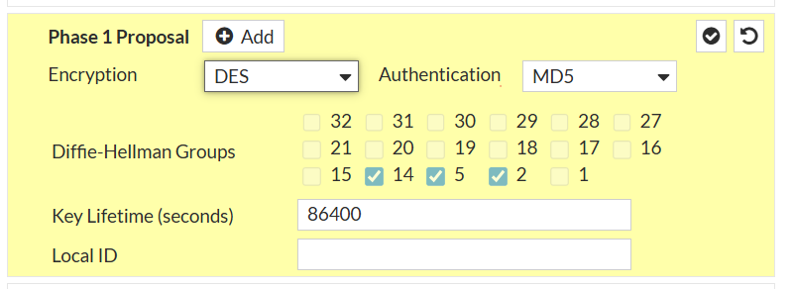
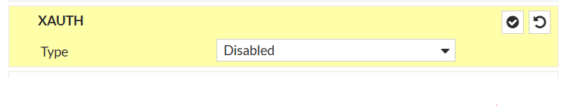

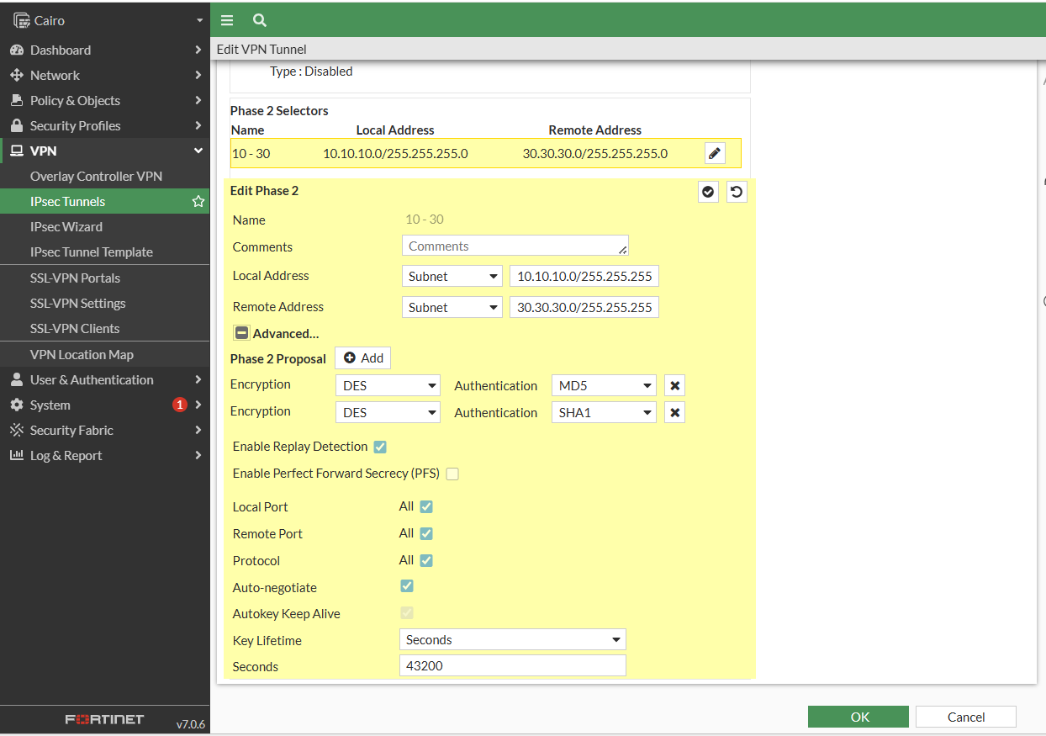
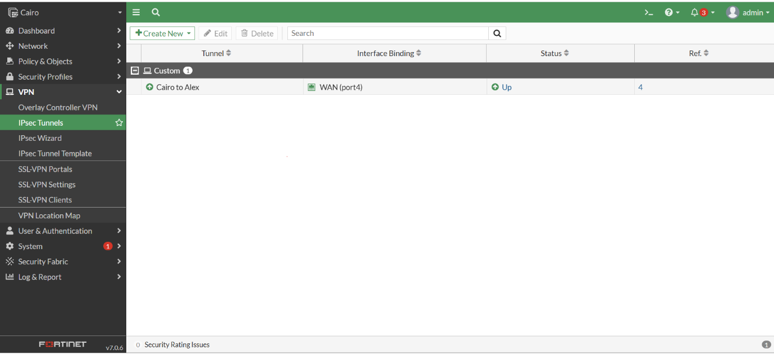
Alex:
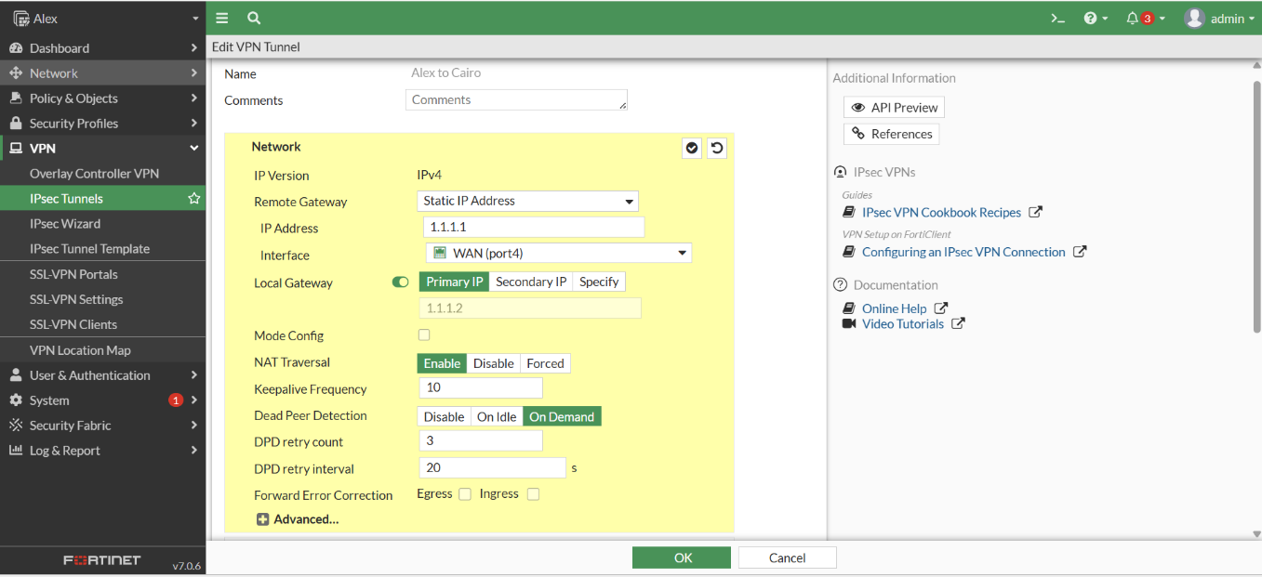
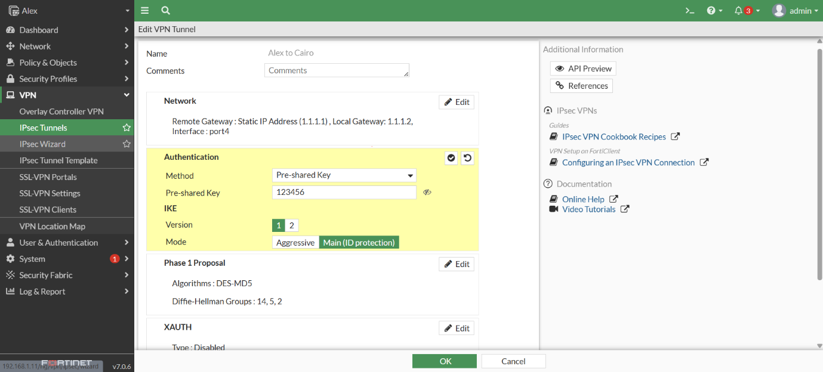
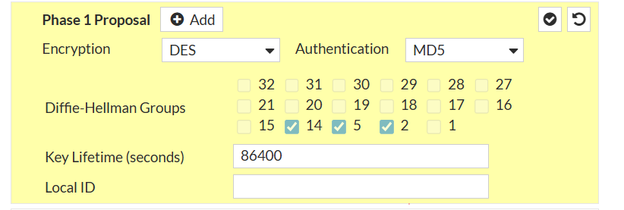

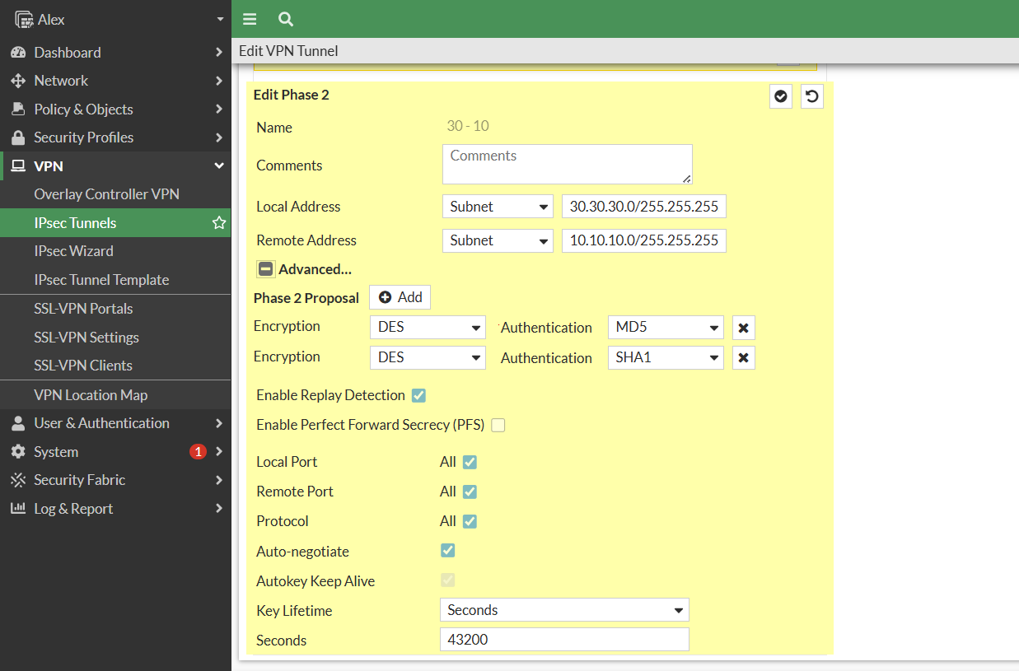

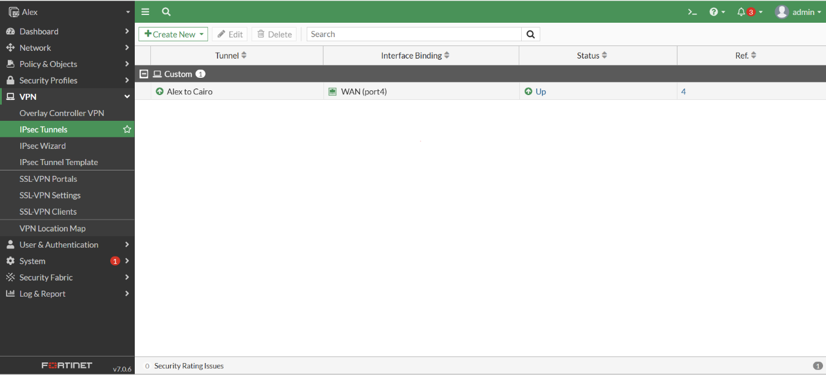
- Configure the static route
Cairo:
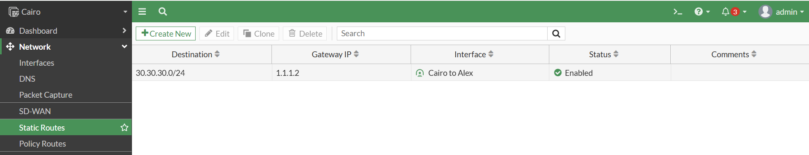
Alex:
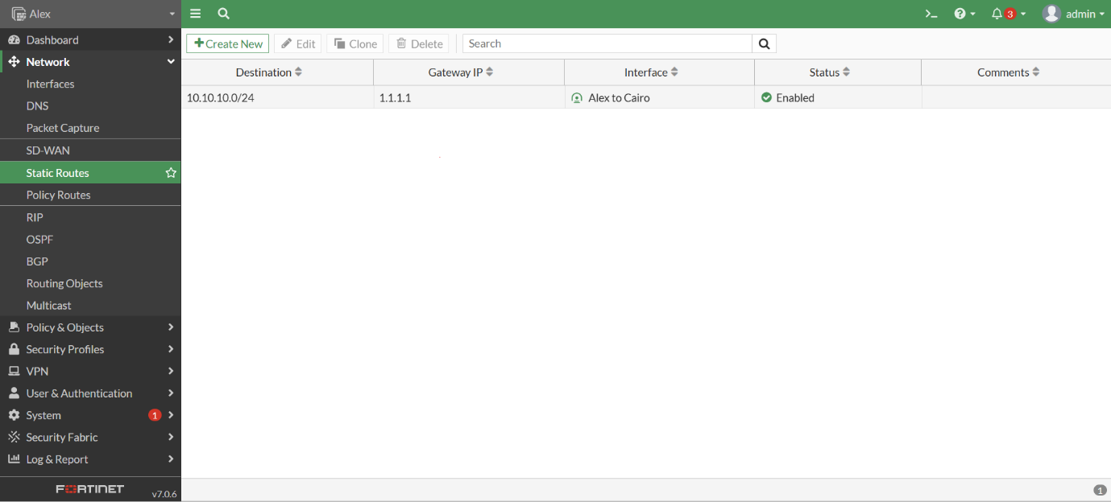

- Configure the policy between network 10.10.10.0 and 30.30.30.0
Cairo:
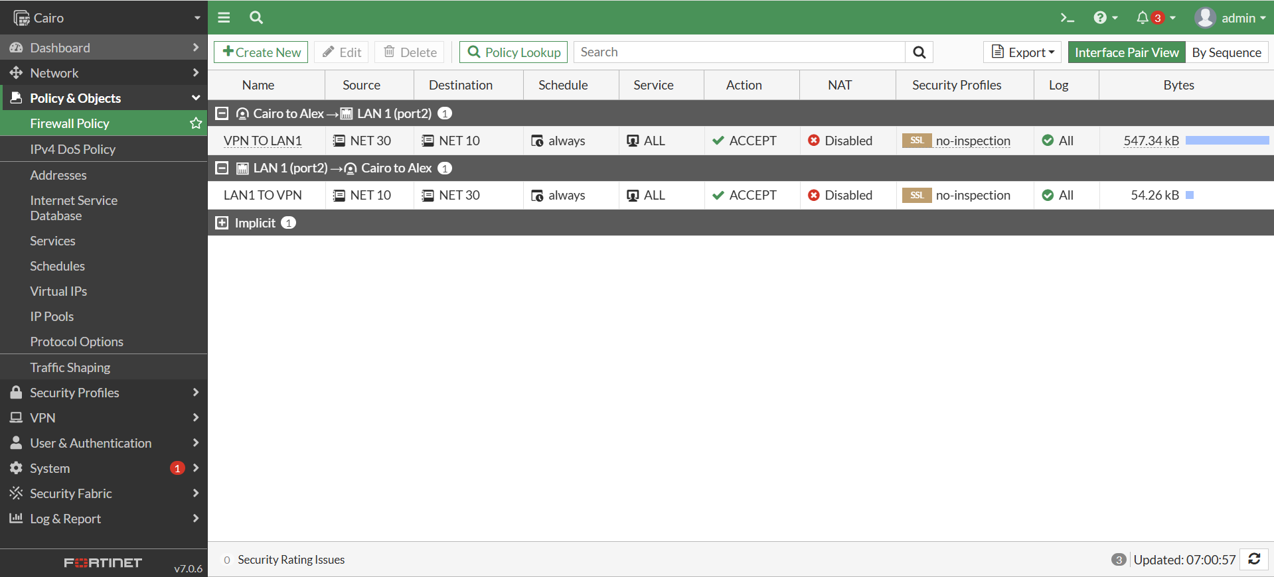
Alex:
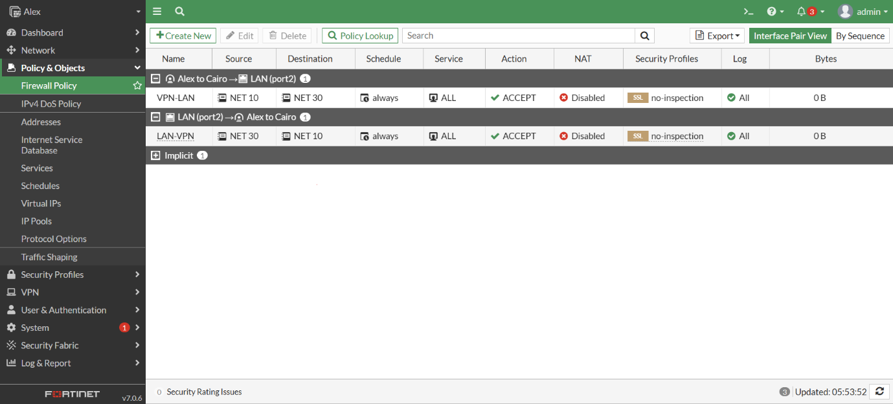
So the Vpn tunnel now is up and running
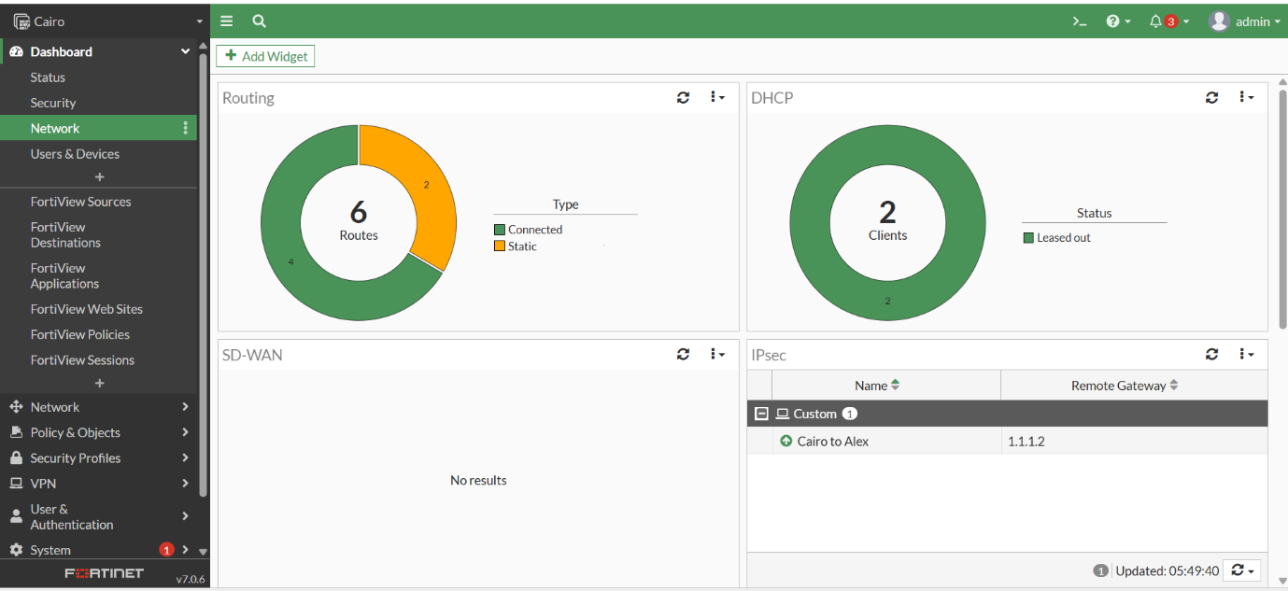

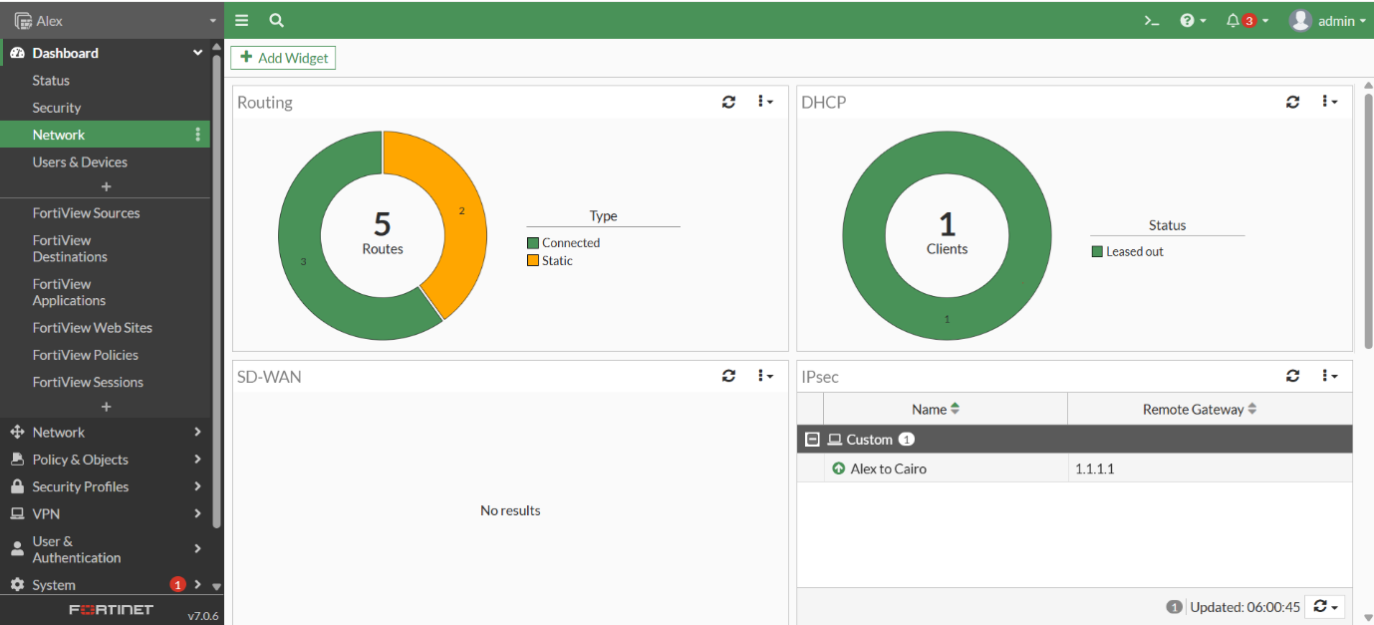
Test Results:
So let us see the result when we ping from PC-1 to PC-3
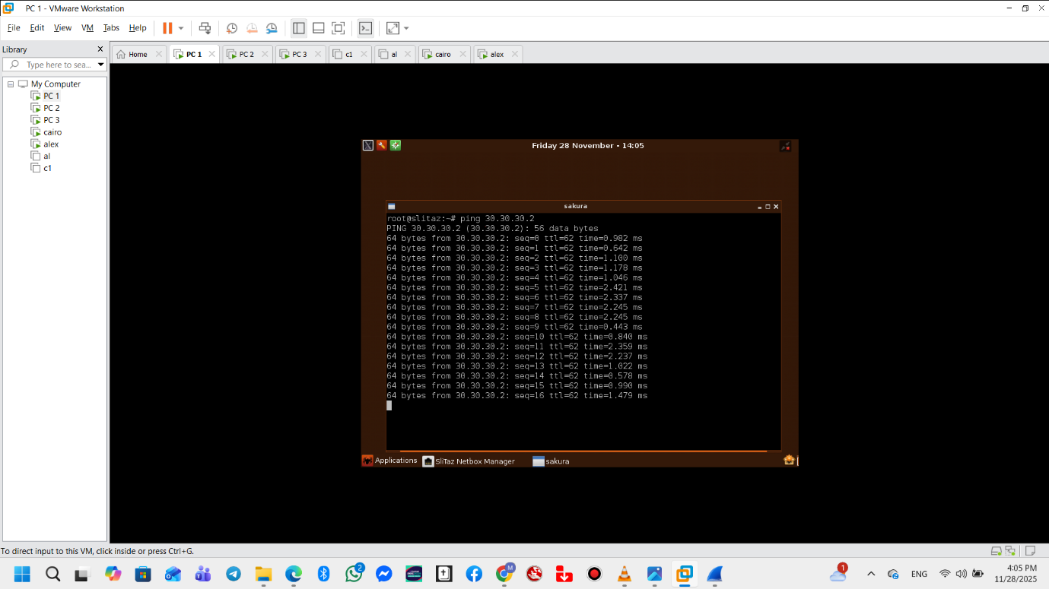
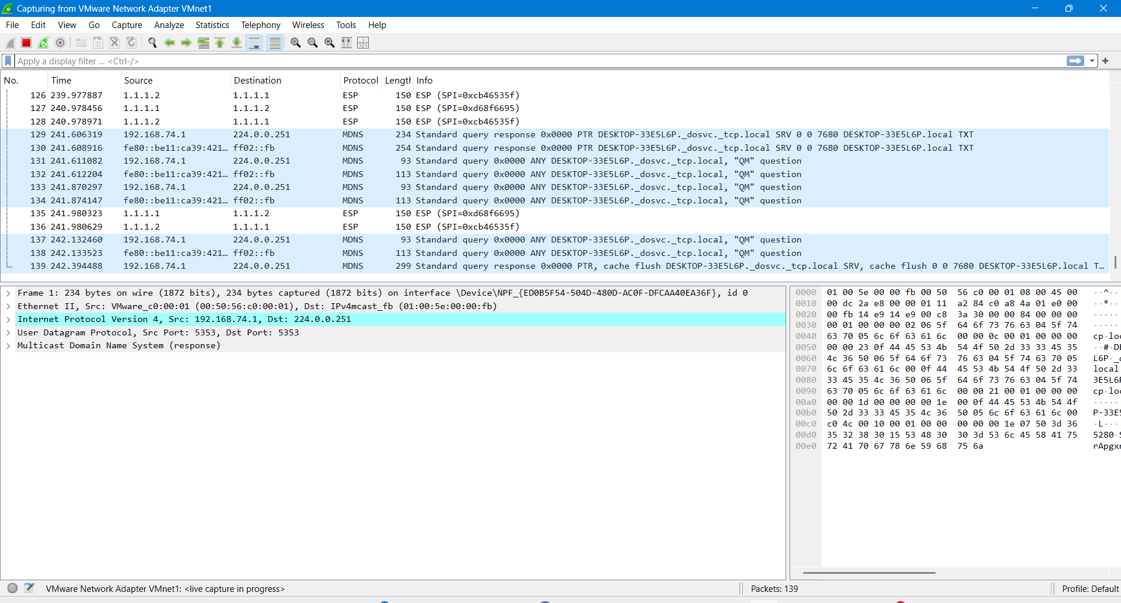
From PC-3 to PC-1
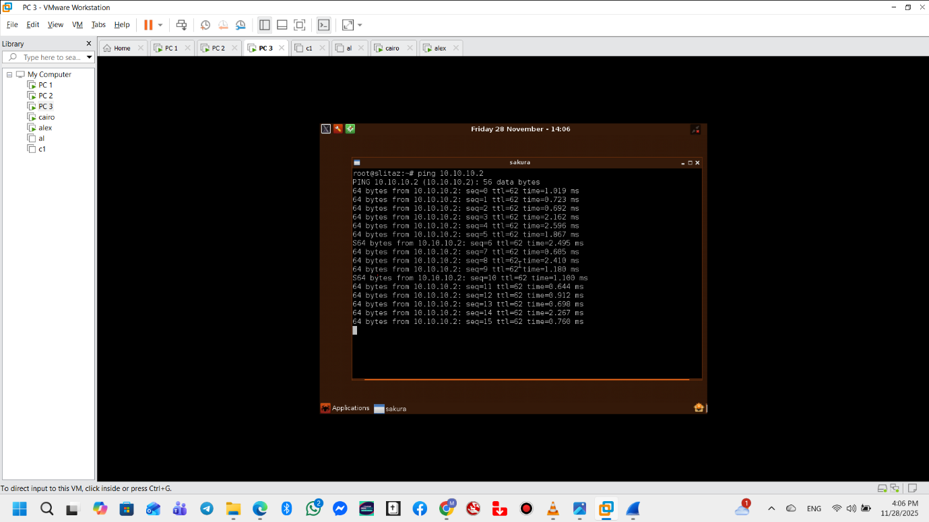
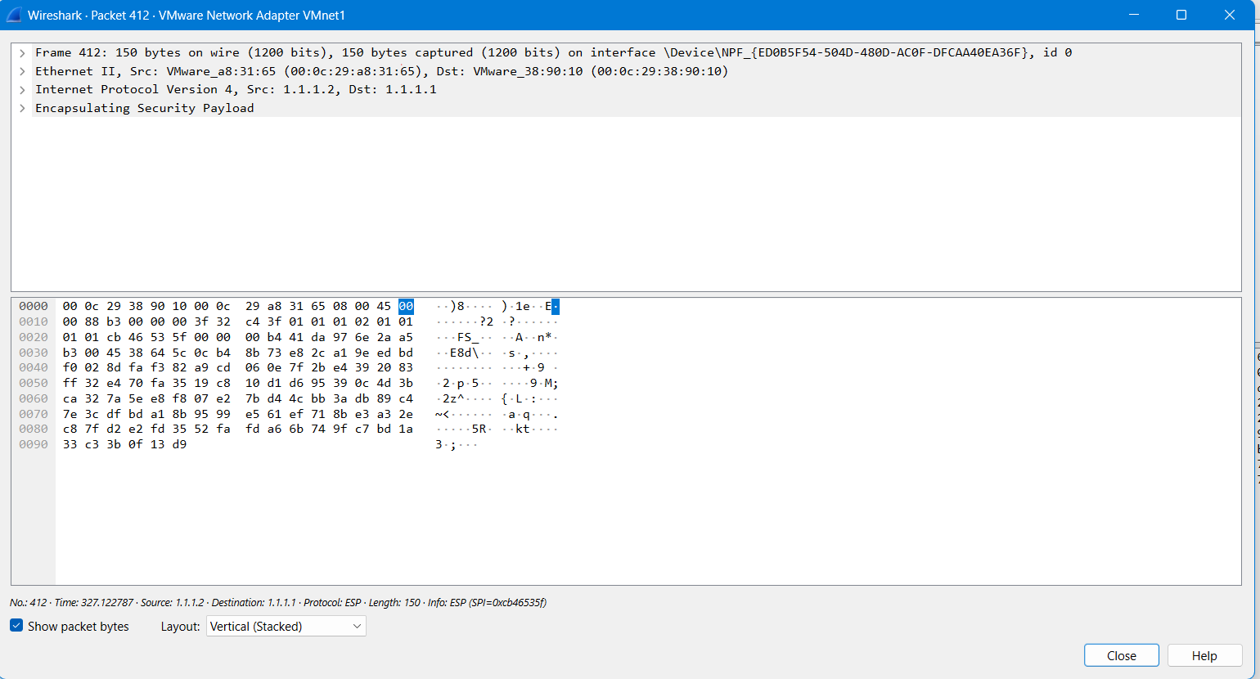
Comment:
The connectivity test results between PC-1 and PC-3 are successful because we established traffic selector from the network 10.10.10.0 to 30.30.30.0

Ping from PC-1 to PC-2
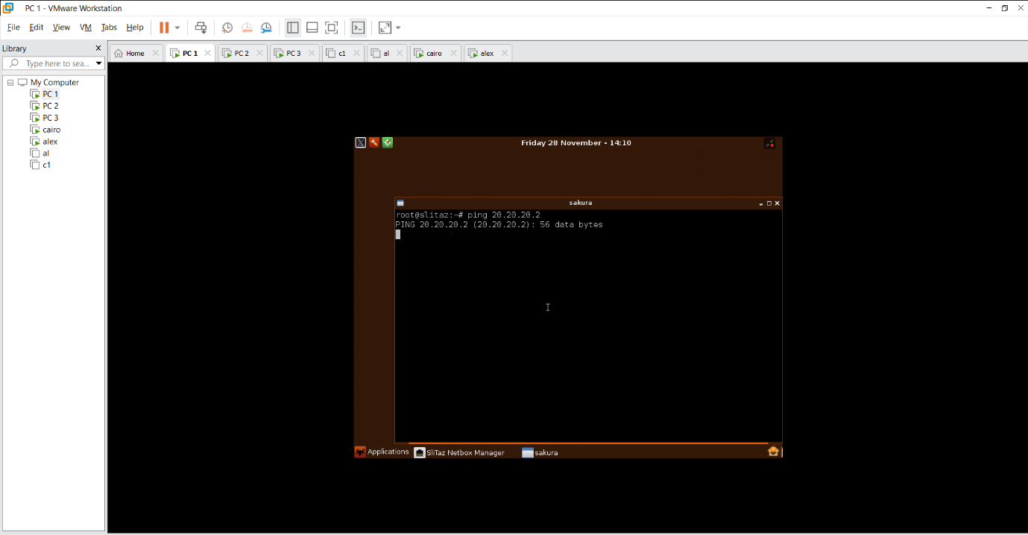
Comment:
The connectivity test results between PC-1 and PC-2 have failed because there is no traffic selector between network 10 and network 20 so the result is as expected

